If you want to enter your blooms into the SEMDS Dahlia Show here is a list of items that will be helpful in staging your blooms. There will be other experienced growers at the show that will be willing to advise you but it is always better to know a little bit more about what you are getting into.
- One box to hold all of your items. I use a collapsible plastic crate (CleverMade brand purchased at Sam’s Club). Don’t use a paper box because it will get wet and likely collapse.
- 2-3 old towels to place on work table
- One cutting board
- One small very sharp knife or secateur for trimming your flower stems
- One large knife for cutting floral foam (I use an inexpensive bread knife)
- One pair of small trimming scissors for fine trimming
- Pens and Pencils
- Roll of paper towels
- Small plastic bucket (dollar store) to hold the wet floral foam when staging
- Trash bag or trash bucket for scrap floral foam and dahlia scraps
- Show Booklet - 2024 booklet will be posted at semds.org about 2 weeks prior to show.
- Current copy of the ADS Classification and Handbook of Dahlias
- Blank show tags (provided by SEMDS). Each bloom you display needs to have a tag on it with your name and bloom name and description [Example: Thomas Edison, B FD PR, 2009]
  - You can use all your extra return address labels for your name on the show tags
  - You can also fill out the tags at home the night before to save time when staging and your tags will stay a lot dryer.
- 2-3 Ziploc bags to carry all your paper products
SEMDS provides:
- All Vases
- Floral Foam, Wedges
- Plastic Bucket to transport/hold floral foam
- Blank show tags
Tips for transporting your blooms to the show:
- Using wood dowel rods clipped to stems with dollar store hair clips will help support your blooms during transportation.
Showing Dahlias
Don’t be afraid to enter your blooms in the show. It’s the only way you really learn. There are 3 main exhibitor classifications:
- Novice – anyone exhibiting dahlias for the first time. You can exhibit in this category for 3 years
- Small Grower – all members growing from 1 – 150 dahlias
- Large Grower – all members growing 151 dahlias or more
As a Novice you will be competing with other Novices which will result in more Blue Ribbons!

Just the Basics on show quality blooms
- Fresh, clean flower heads having a bright color
- Shown at peak of development, center full [no blown centers]
- Bloom must be disbudded (disbud early to reduce scarring)
- Flower head facing at 45◦ angle (some exceptions)
- Flower heads true to type on a well-proportioned stem
- The first set of opposing leaves beneath the flower must be left attached
Reference the Show Bulletin for all the details. The Show Booklet will be posted on SEMDS website.
Every show has unique rules and competition classes so make sure you read through the show booklet carefully. Many of the regional shows have so many classes it can be overwhelming. The Dahlia Society of Ohio does baskets. The MDC and ADS National Shows have many floral arrangement categories, local sponsored classes, and photography classes.

SEMDS show booklet

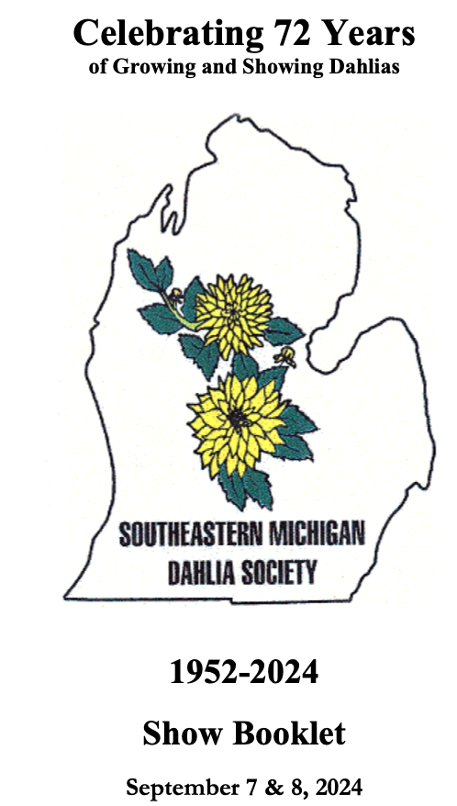
Southeastern Michigan Dahlia Society (S.E.M.D.S) Mission
Promoting & Supporting the Growing, Showing, and Enjoyment of Dahlias in our community

